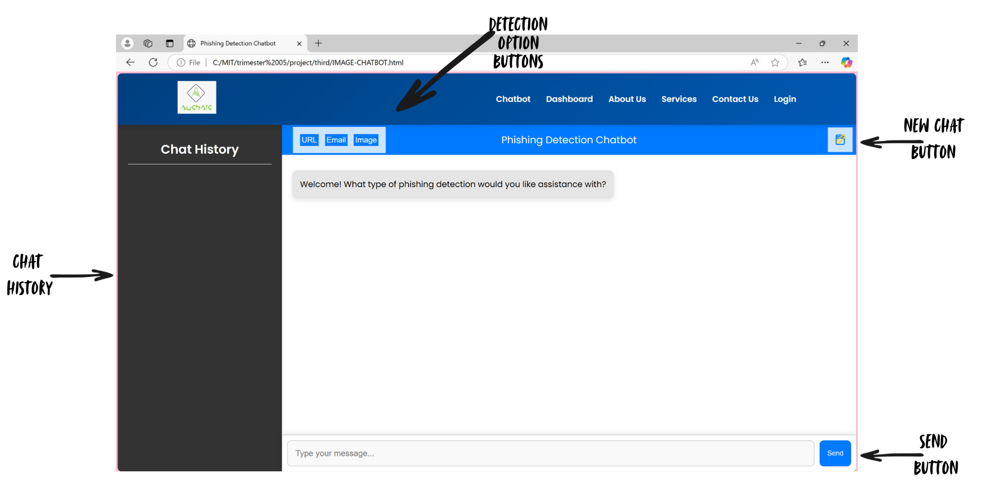
BEFORE

AFTER

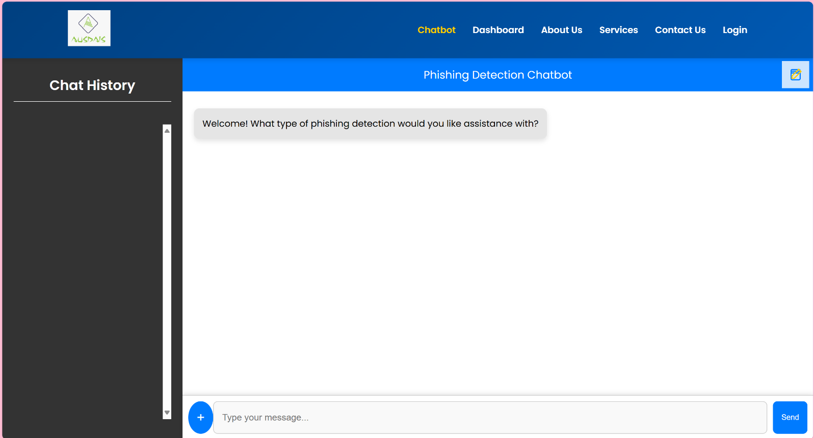
- Remove the three separate chatbots connected to the main chatbot. So, now only have one chatbot for all three services (URL, email and image)
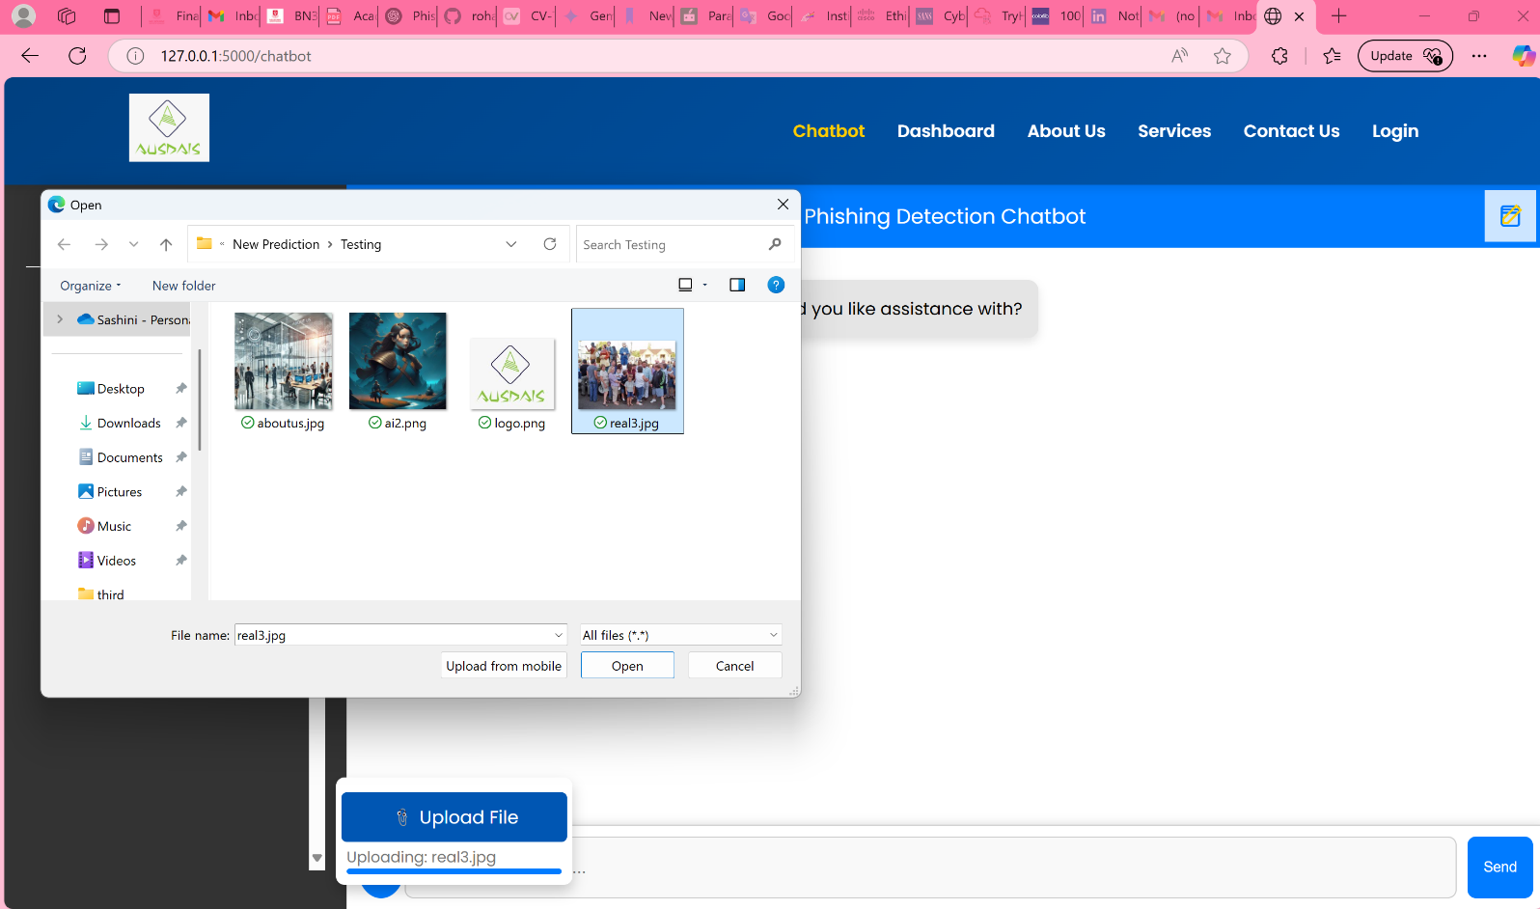
- Add an upload button where users can upload images and PDF files (Not fully done yet).

- Waiting for the chatbot model to be done to connect to the chatbot interface.

